Fred the Frog

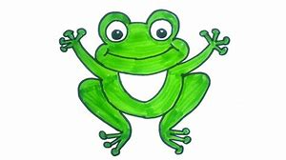

This is Fred, the frog.

Fred likes to hop.

Did Fred hop up on the bench?

Yes he did.

Did Fred hop up on my bed?

Yes he did.

“Yuck. Get off Fred!”